TDM: (Time Division Multiplexing)

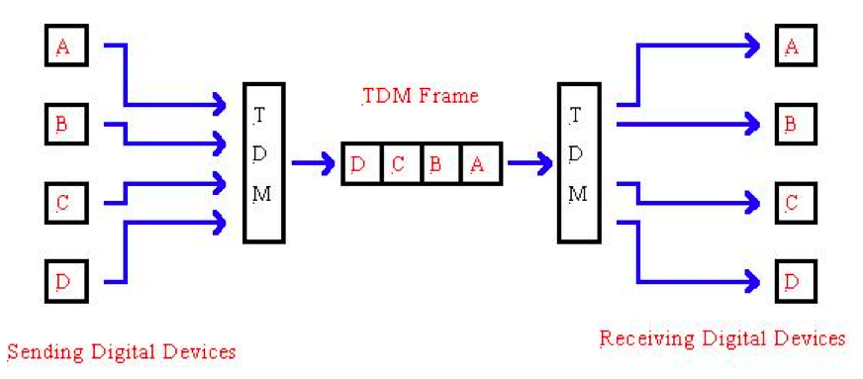
Types of TDM:
- Synchronous TDM:

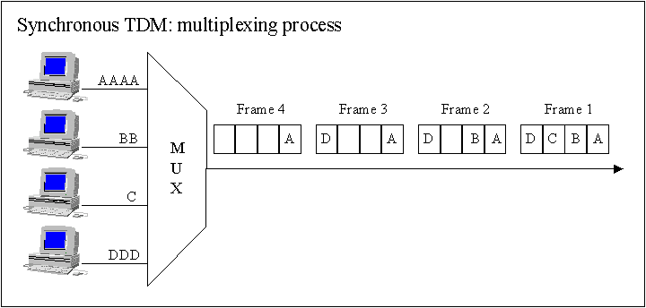

- Asynchronous TDM:

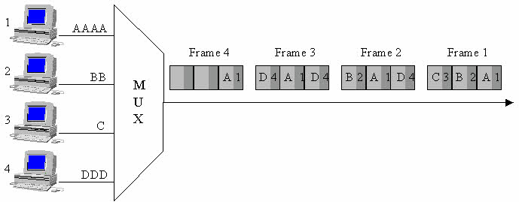

FDM:(Frequency Division Multiplexing)

